|  |
| --- |
| **OTHER DATABASE OBJECTS** |
|

1. Create a sequence to be used with the primary key column of the DEPT table. The sequence should start at 200 and have a maximum value of 1000. Have your sequence increment by ten numbers. Name the sequence DEPT_ID_SEQ.

Create Sequence dept_id_sequence start with 200 increment by 10 maxvalue 1000;

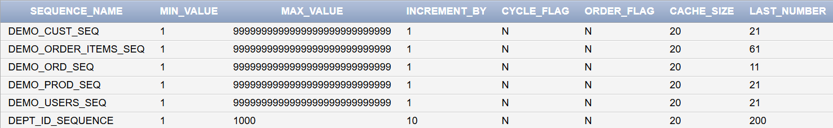

1. Write a query in a script to display the following information about your sequences: sequence name, maximum value, increment size, and last number

SELECT sequence_name, max_value,increment_by AS increment_size,last_number FROM user_sequences WHERE sequence_name = 'DEPT_ID_SEQUENCE';

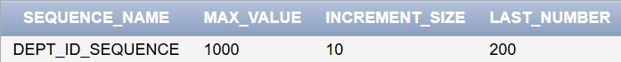

1. Write a script to insert two rows into the DEPT table. Name your script lab12_3.sql. Be sure to use the sequence that you created for the ID column. Add two departments named Education and Administration. Confirm your additions. Run the commands in your script.

Insert into departments values(dept_id_sequence.nextval,'HR',111,1010,'US','United States'); Insert into departments values(dept_id_seq.nextval,'Admin',112,1011,'IN','India');



1. Create a nonunique index on the foreign key column (DEPT_ID) in the EMP table.

Create index emp_dept_index on Employees(department_id);



1. Display the indexes and uniqueness that exist in the data dictionary for the EMP table.

SELECT index_name, uniqueness FROM user_indexes WHERE table_name = 'Employees'; Output :

Index_name : EMPLOYEE_INDEX Uniqueness : NONUNIQUE